# Graphical User Interface :

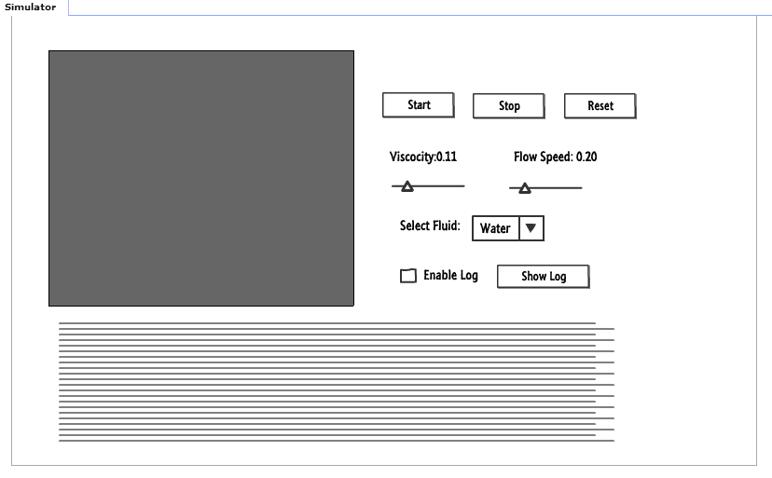

**Work Flow for the above GUI:**

1. Grey Box:



The Grey box (container) is used to replicate or reproduce the fluid simulation output based on the physical parameters that the user selected.

1. Start Button:



When the user clicks on the Start Button, the simulation starts its execution with the default or the selected physical parameters like Viscosity, Flow Speed and Fluid. In short the simulator picks up its initialization. This initialization works based on the Lattice Boltzmann | Navier-Stokes engine substation.

1. Stop Button:



When the user clicks on the Stop Button, the simulation gets stopped with all the ongoing executions.

1. Reset Button:



When the user clicks on the Reset Button, the simulator resets / clears all the current physical parameters with the default case parameters. Also it can be used to start a new simulation with other new physical parameters.

1. Viscosity:



User should be able to select the appropriate or required Viscosity value for the simulation.

1. Flow Speed:



User should be able to select the appropriate or required Flow value for the simulation.

1. Select Fluid:



User can be able to select the type of fluid for which he wants to make the simulation for.

1. Enable Log:



User can be able to Enable or Disable the Log for the simulation which is currently running.

1. Show Log:



Clicking on the “Show Log” button will help the user to go through the log for his / her ongoing simulation which is shown in the below log container.

1. Log Container:



Here is the log container which will show all the simulation log for the user which helps to diagnosis the behavior of the simulation.